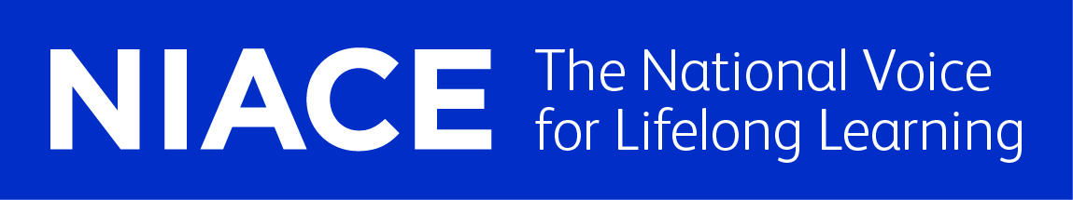
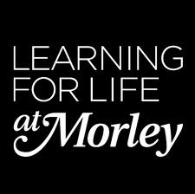
Educate Out Prejudice Curriculum Pilot
Brush up your English Level 2 - Pauline Cohen
Contents:
- Lesson Plan – Pre-Exhibition Visit (pp. 2 – 5)
- Lesson Plan – Exhibition Visit (pp. 6 – 9)
- Group Profile with Equality and Diversity Statement (pp. 10 –11)
- Resources (pp. 12 – 17)

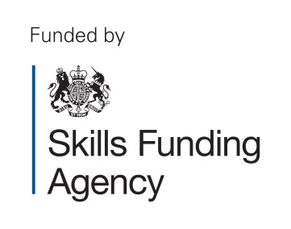
The creation of this material by Morley College has been financed by the Skills Funding Agency Equality and Diversity Innovation Fund 2013/14.Copyright in this material is vested in the Crown but it is made freely available through an Open Government Licence. This licence enables you to use and adapt the material but you must attribute Morley College as the creator and include details of the licence. Full details of the licence are available at http://www.nationalarchives.gov.uk/doc/open-government-licence/
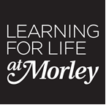 LESSON PLAN Pre-Exhibition Visit Essential Skills 2013-2014

COURSE TITLE:  Brush Up Your English – L2 | TUTOR:  Pauline Cohen | DATE OF LESSON  3rd February 2014 | NO. OF LEARNERS  13
LEARNING OUTCOMES  (What the student will know or be able  to demonstrate by the end of the session)  Use the internet to locate information on LGBT celebrities  Rt/L2:6 Use organisational features and systems to locate texts and information  Aim: Use the Internet to find information on at least one LGBT celebrity. Write notes about his/her background, profession, celebrity status, statements about his/her sexuality. This research will form the basis for writing in a follow-up lesson. |  | By the end of the session students will be able to:  - Recognise and understand key terms associated with using the internet  (e.g. www, internet browser)  - Use the internet to locate information  - Use a Tablet to take photographs and access the internet  Context: Lesson planned to meet curriculum aims, with LGBT focus chosen as real-time topic with the advantages that (a) Students could physically view the exhibition (b) Would recognise at least some of the celebrities (c) It offers a tangible opportunity for follow-up activities in writing and discussion

TIME | STAGE | INSTRUCTIONS | RESOURCES
5 min | Register; collect/return homework
5-10 min | Warmer | Tutor: Explain activity; hand out worksheets; check answers and give feedback; show list of possible words on board.  Students: Work on own to write as many words of 2 to 5 letters they can from these nine letters (MIMNERER T, with each letter to be used once only and every word to contain T).  Extension: write 6-9 letter words. | Whiteboard  Word Wheel 11 Puzzle sourced at www.activityvillage.co.uk
15 min | Recognise and understand some key internet terms | T: Ask students if/how/when they use the internet; encourage discussion; explain activity (matching terms and meanings); hand out flashcards; give 1:1 support as necessary; encourage discussion and give feedback on completion of activity.  Students: Engage in discussion; work in pairs to match terms and meanings; respond to questions | Whiteboard  Flashcards matching exercise/web vocabulary
15 min | Induction to Microsoft Surface Tablet | Tutor: Explain activity  IT Technicians: hand out Tablets; give instruction on how to use etc.  Students: Log on to individual tablets; listen to and follow instructions. | Microsoft Surface Tablets
35 min | Locating information on the internet | Tutor: check that students are connected to the internet; explain activity and hand out worksheets; observe and give 1:1 support as necessary; check answers and give feedback.  Students: Work individually or in pairs to search internet for answers to the quiz. Complete answer sheet.  Extension: (internet surfing worksheet) | Microsoft Surface Tablets  Whiteboard  Internet  Internet Surfing sourced at www.bbc.co.uk  Internet activity quiz (update and/or change to match students’ interests/fewer questions). Source: Skills Workshop
10 min | BREAK
50 min | View LGBT exhibition and locate information on individual celebrities | Tutor: Explain activity/LGBT exhibition; take class down to exhibition (allow15-20 min); back in classroom, ask students who they recognised and why; show them image of exhibition on whiteboard and ask students to put names to faces; ask students to pick two celebrities who interest them and use internet to find answers to ‘Celebrity Questions’.  Students: View exhibition; work on own using Tablets to take photos/videos; make notes of celebrities they recognise. Back in classroom, engage in discussion and respond to questions; pick celebrities of interest and use internet to answer celebrity questions and make notes. | Microsoft Surface Tablets  Whiteboard  Internet  LGBT exhibition  Digital image of exhibition
10 min | Plenary | Tutor: Q and A to check learning; information found on celebrities  Students: Respond to questions and engage in discussion

EVALUATION OF LESSON (Were the learning outcomes achieved? What was successful? What could be improved? Is there anything that needs to be carried over to the next session?)

The students were reasonably comfortable using the Internet to find information as a result of owning smart phones and Tablets. However, they were unclear about Internet terms, so the matching exercise worked well and generated a fair amount of discussion. Students only recognised a few of the more well-known celebrities. The exhibition would have worked better for this group of students if the photographs had been labelled e.g. with the person’s name and profession. The ability to later show the exhibition on the white board and to match names to faces led to some useful discussion.

There wasn’t enough time for students to complete their research, so they were asked to do this for homework.

There were some problems with getting connection on some of the tablets, but students were able to use their smart phones. An alternative was to ask students to use computers in the library, or to have relocated the lesson to an IT room.

The topic worked well in adding interest and purpose to the overall aims of getting students to a point where they had (a) a better understanding of internet terms and (b) using the internet for research/as a source of information.

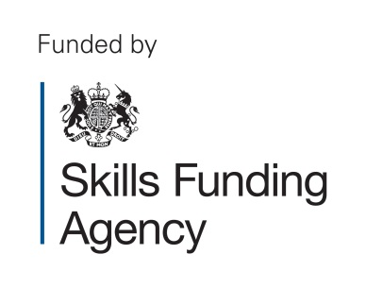
The creation of this material by Morley College has been financed by the Skills Funding Agency Equality and Diversity Innovation Fund 2013/14.Copyright in this material
is vested in the Crown but it is made freely available through an Open Government Licence. This licence enables you to use and adapt the material but you must attribute
Morley College as the creator and include details of the licence. Full details of the licence are available at http://www.nationalarchives.gov.uk/doc/open-government-licence/

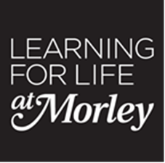 LESSON PLAN Exhibition Visit Essential Skills 2013-2014

COURSE TITLE:  Brush Up Your English – L2 | TUTOR:  Pauline Cohen | DATE OF LESSON  5th Feb 2014 | NO. OF LEARNERS  13
LEARNING OUTCOMES  (What the student will know or be able to  demonstrate by the end of the session)  Aim: To recognise and understand some key vocabulary related to LGBT/and sexuality.  To complete a short text (200-300 words), with paragraphs and using information sourced from the internet about an LGBT celebrity  Wt/L2:1 Plan and draft writing  Wt/L2:2 Judge how much to write and the level of detail  Wt/L2:3 Present information and ideas in a logical format using paragraphs where appropriate |  | By the end of the lesson students will be able to:  - Recognise and understand some key vocabulary related to LGBT/ sexuality.  - Plan, draft and complete a short text about an LGBT celebrity from the exhibition.  Context: Lesson planned to meet curriculum aims with LGBT focus as a tangible, real-time topic. The lesson follows on from a previous one focusing on using the internet for research. That source material is to be used to complete a piece of writing. A third lesson will make use of the student’s knowledge and understanding about LGBT in a discussion about gay marriages.

TIME | STAGE | INSTRUCTIONS | RESOURCES
5 min | Register; collect/return homework
15-20 min | Warmer  Recap on last session | Tutor: Explain activity; hand out worksheets; check answers and give feedback; show list of possible words on board.  Q and A to check recollection/understanding of previous lesson.  Students: Work on own to write words of 2-5 letter words from these letters WSFAONLE K Each letter to be used once only and each word to contain K.  Extension: write 6-9 letter words; write sentences.  Respond to questions and engage in discussion | Whiteboard  Word Wheel 12 Puzzle sourced at:  www.activityvillage.co.uk/word-wheels
20 min | Recognise and understand some key words and terms related to LGBT and sexuality | Tutor: Ask students to define LGBT/what they understand; explain activity (matching terms to meanings); hand out flashcards; observe and check that students what they’re doing; give 1:1 support where necessary; encourage discussion and give feedback on completion of activity.  Students: Work in pairs to match terms to meanings; engage in discussion; respond to questions. | Whiteboard  Flashcards (matching exercise)
30 min | Plan writing | Tutor: Q and A and discussion to check what students remember about the writing process and planning writing; select a celebrity from LGBT exhibition; show students the information researched on the net; model planning on white board. Observe students as they work to make sure individuals understand what they are doing and give 1:1 support as needed; give feedback  Students: Respond to questions and engage in discussion; work on own to check that they have enough information on their chosen celebrity; plan writing. | Whiteboard  Sample internet research on LGBT celebrity
10 min | BREAK
50 min | Draft, proof read and write short text on LGBT celebrity | Tutor: Q and A to check students’ understanding of each process; write a model paragraph on white board; ask students to read and look for any mistakes; demonstrate proof reading and correcting; ask students to use their plan and write a draft, check it for mistakes and write neat copy. Observe students as they work make sure individuals understand what they are doing and give 1:1 support as needed; recap on different stages of the task.  Students: Work on own and use plan to first, draft text on celebrity; then proof read, and then write neat copy. | Whiteboard  Student’s LGBT celebrity research
10 min | Plenary | Tutor: Q and A to check learning  Students: Respond to questions and engage in discussion | Homework: complete writing and illustrate with a celebrity picture.

EVALUATION OF LESSON (Were the learning outcomes achieved? What was successful? What could be improved? Is there anything that needs to be carried over to the next session?)

Key vocabulary matching exercise was successful as majority of students were very unclear about terms. It generated some good discussions with some students questioning previous misunderstandings.

The Pink List had come up during their research, so needed to clarify what it was.

Some students still very unclear about the need for/how to/and purpose of planning and so needed lengthy 1:1 support.

Students were quick to identify favourite LGBT celebrities (e.g. Claire Balding, Gok Wan) possibly due to their high-profile TV appearances. However, this was the first time the students had considered the celebrity’s LGBT status, but responses were positive and they were recognised as ‘inspirational’ figures.

Overall, the LGBT topic added interest and something tangible to the larger task of producing a piece of writing. It enabled students to identify with personalities they already felt they knew and, in some cases, made the task of writing that much easier. It also enabled students to learn about a community they had little understanding of and perhaps made the students question previously held prejudices.

Some good pieces of writing were produced.

The creation of this material by Morley College has been financed by the Skills Funding Agency Equality and Diversity Innovation Fund 2013/14.Copyright in this material
is vested in the Crown but it is made freely available through an Open Government Licence. This licence enables you to use and adapt the material but you must attribute
Morley College as the creator and include details of the licence. Full details of the licence are available at http://www.nationalarchives.gov.uk/doc/open-government-licence/

Essential Skills 2013-14

Group Profile with Equality and Diversity Statement

Course Title: Brush Up Your English

Course Code: | FEF002B | Level | Level 2
Number on register | 15 | Tutor: Pauline Cohen
Comments on the students, class dynamics
This is a diverse group in terms of age, ethnicity and abilities. There are 9 women and five men, with ages ranging from 19 to 60. Backgrounds vary to include, Caribbean, Polish, Iraqi, Turkish, Ghanaian and Nigerian.

The students have a mix of qualifications; including L1 literacy, BTEC, NVQ and one student has a degree in economics from her home country. The majority are in full-time employment and some are also studying other subjects while others have young families.

One student has arthritis and has issues with mobility and a second has a problem with his eyesight.

Differentiation for this group based on the above
- Ensure that worksheets are printed on buff-coloured paper for A and seat him at the front of the class
- Once seated, avoid moving B
- For pair and group work, ensure C works with female students
- D, A and E are often late to class because of work, while C works shifts so sometimes misses the start or end of lessons. F has to organise childcare. So include at least 15mins warmer at start of lessons.
- Ensure extension work for students working at higher ability level

Equality and Diversity and Safeguarding
As part of the induction process, the students were made aware of the College’s policies on Equality and Diversity. They understand that the College has a policy of treating everyone equally - irrespective of race, gender, disability, language and age. They know that if they feel that any of these policies have been breached, there is an accessible complaints procedure.

The students understand that the College has a Safeguarding Policy and they can talk to me about anything that is concerning them and that I will be supportive and helpful.

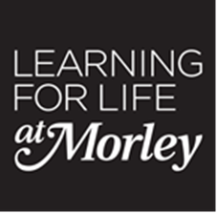
Embedding LGBT – Brush up your English Level 2: Resources.

- ‘The LGBT exhibition at Morley College’ by I.S. (pp.13-14)
- ‘LGBT EXHIBITION AT MORLEY COLLEGE’ by S.J. (pp.15-16)
- ‘The Lesbian, Gay, Bi-Sexual and Transgender Exhibition at Morley College’ by V.T. (pp.17)

The creation of this material by Morley College has been financed by the Skills Funding Agency Equality and Diversity Innovation Fund 2013/14.Copyright in this material is vested in the Crown but it is made freely available through an Open Government Licence. This licence enables you to use and adapt the material but you must attribute Morley College as the creator and include details of the licence. Full details of the licence are available at http://www.nationalarchives.gov.uk/doc/open-government-licence/

The creation of this material by Morley College has been financed by the Skills Funding Agency Equality and Diversity Innovation Fund 2013/14.Copyright in this material is vested in the Crown but it is made freely available through an Open Government Licence. This licence enables you to use and adapt the material but you must attribute Morley College as the creator and include details of the licence. Full details of the licence are available at http://www.nationalarchives.gov.uk/doc/open-government-licence/

The LGBT exhibition at Morley College
February is Lesbian, Gay, Bisexual and Transgender History Month. Morley College is holding an LGBT exhibition to celebrate this event. The exhibition features photographs of 26 professional and famous people who were chosen from the Independent on Sunday’s Pink List 2013. The purpose of the exhibition is to show that many well-known and influential people belong to the LGBT community.
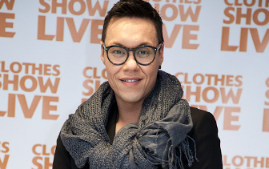
Among the photographs featured in the exhibition is one of Gok Wan, the well-known English fashion stylist and TV presenter. He was born in Leicester on 9 September, 1974. His father is Chinese and his mother is English. He trained to be an actor at the Central School of Speech and Drama. He became famous in 2006 with the Channel 4 TV show ‘How to Look Good Naked’. He is also presents many other TV shows, such as ‘Miss Naked Beauty’, ‘Gok’s Fashion Fix’ and ‘Gok’s Style Secrets’. Gok is openly gay and he is in 45th place on the Pink List 2013.
Gok Wan is a very inspirational and influential person. He helps overweight and self-conscious people to feel confident about themselves. He shows them that they are beautiful as they are. He was also a self-conscious and was bullied for being an overweight teenager. In spite of his bad experience, he was able to lose weight and became a compassionate but strong adult. He turned his weakness into his strength.

I.S.
07/02/2014

LGBT EXHIBITION AT MORLEY COLLEGE

The LGBT Exhibition is a celebration for gay, lesbian, bisexual and transgender community. It is a collection of photographs of people; many are easily recognizable from the media, others that are not as well known. The main purpose is to show many famous and inspirational people belong to its community. Also LGBT as a Pink List that recognises the most influential people in the UK.

I am writing about two celebrities that belong to the LGBT Community, Claire Balding OBE and Gok Wan, that can inspire many people to be confident about them self and their sexuality.

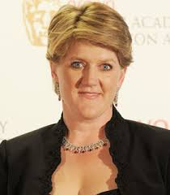

Claire Balding can be an excellent example of some one who is inspirational because she was a leading amateur flat jockey and Champion Lady Rider in 1990. She also was the first woman to work in an industry of horse racing presenting; also the first female to present the Royal Ascot on BBC1, which at the time was an all male industry. She also now presents all types of sport programme.
Claire did not know she was gay until her 20s but feels liberated now she is open about being lesbian.

In 2012 Claire come 2nd on the Pink List, She is in a civil partnership with newsreader Alice Arnold.

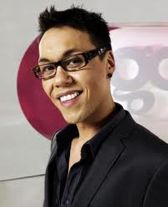

Gok Wan is a never excellent example of a person who is inspirational because has an overweight teenager he known he what to change his life around, so then total loss weight of an 11stone from 21stone to 10stone from the age of 20 year old, then trained in performing arts at the Central School of Speech and Drama. Then he went in the industry of fashion. Gok work with many celebrities, he then become a fashion consultant by offering his opinions to fashion magazines which several published internationally. His big break was in 2006 with C4 TV show, How to Look Good Naked. The first time admitting he’s gay to his family was by bringing a boyfriend home for dinner.

WRITTEN BY
S.J.

V. T.
06 February 2014
The Lesbian, Gay, Bi-Sexual and Transgender Exhibition at Morley College.
Morley College is holding the LGBT exhibition as part of its celebration of the Lesbian, Gay, Bi – Sexual and Transgender month. The college has a collection of famous people, some celebrities, writers and those in entertainment.
The Independent first published the “Pink List” in 2000; this was a list of the most influential people who was brave enough to come out. Today there are more than 1,000 people who were nominated.
I shall be looking at Gareth Thomas the retired professional Welsh rugby player.
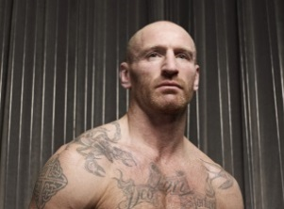
Gareth was born 25 July 1974 to Welsh parents, and played school boy rugby; he played Rugby Union at Bridgend and for Wales and went on to play Rugby League for the Crusaders in the super league and went represented Wales as Captain for the Six Nations Cup.
Gareth appeared in a few TV celebrity programmes like Celebrity Big Brother, a cameo of his self in Stella Street and a brief appearance in Dancing on Ice where he was advised to drop out due to motion sickness during a training session. Gareth was also the TV analyst for the 2011Rugby World Cup.
In 2009, Gareth announced he was gay after retiring from playing professional Rugby, he told the media “I don't want to be known as a gay rugby player. I am a rugby player; first and foremost I am a man". Gareth was the first professional rugby player to make this announcement. Gareth struggled with his sexuality and prayed to be straight. In 2001 he married Jemma, this marriage was to last seven years when he filed for divorce that was finalised in 2009, and throughout the marriage Jemma suffered 3 miscarriages.

